File and Folder Structure

## Main Folders

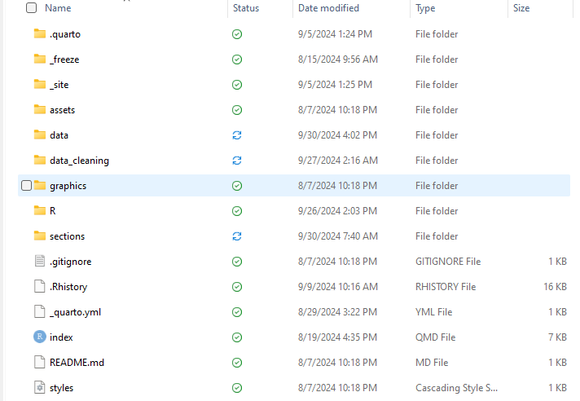

### .quarto

Created automatically by the program when the HTML outputs are rendered. Does not need to be looked at typically.

### _freeze

Created automatically by the program when the HTML outputs are rendered. Does not need to be looked at typically.

### _site

Created automatically by the program when the HTML outputs are rendered. Does not need to be looked at typically.

### assets

Contains a code file that applies customized styling to the HTML output.

### data

Contains data files used and/ or generated for the asset map project.

### data_cleaning

Contains files used for converting the structure of the data into a useful form.

### graphics

Contains graphics used for the website.

### R

Contains user-defined custom functions used in various files for the project.

### sections

Contains coding files used to produce the website output.

.gigitnore – Only relevant for github. Prevents specified data files from being shared.

.Rhistory – Only relevant for github.

_quarto.yml – Determines which coding files are included on the resulting website and how they’re structured.

index - Created automatically by the program when the HTML outputs are rendered. Does not need to be looked at typically.

README.md – Template for creating a README page if desired.

styles – Contains the set theme styling code.

# File Structure Within Important Folders

## sections

### about_files

Created automatically by the program when the HTML outputs are rendered. Does not need to be looked at typically.

### .Rhistory

Created automatically by the program. Does not need to be looked at typically.

### asset_map_dashboards

Contains code used for generating the community resource asset map dashboards on the asset map website.

### definitions

Contains code used for generating the definitions page on the community resource asset map map website.

### demographics dash

Contains code used for generating the demographics dashboard page (work in progress).

### demographics_tables

Contains code used for generating the demographics tables page (work in progress).

### resources

Contains code used for generating the resources page (work in progress).

## data_cleaning

### data_by_categories

RDATA file created in the `data_cleaning_asset_map` file containing the data used in the `asset_map_dashboards` file to generate the dashboards on the website.

### data_cleaning_asset_map

Coding file used for structuring data in the appropriate format for creating the community resource asset map dashboards.

### data_cleaning_united_way

Coding file used for cleaning the United Way data and assigning categories to the services.

### intercept_classification_list

Coding file for generating lists of keywords that would be used in the classification of the United Way data based on intercept (work in progress).

### main_category_classification_lists

Coding file for generating lists of keywords used in the classification of the United Way data based on main need categories.

### sub_category_classification_lists

Coding file for generating lists of keywords used in the classification of the United Way data based on sub categories (work in progress).

### resources

Contains code used for generating the resources page (work in progress).

## data

### all_categories

Contains a data table of all 9 categories with their subcategories.

### check_united_way_data

Contains a data table of United Way services manually assigned whose main categories.

### community_resources_map_data

Data entered from the 2021 asset map. This is the data used in the dashboard website.

### keyword_lists

Saved lists of keywords used in the classification of the United Way data into the main need categories.

### prepped_data

Saved cleaned data from the community resource asset map.

### sub_cat_keyword_lists

Saved lists of keywords used in the classification of the United Way data into the subcategories.

### united_way_data

Raw data received from United Way.

### uw_categorized_behavioral_services

Data table containing services categorized under behavioral health services with their assigned subcategories.

### uw_categorized_main_category

Data table containing the full list of filtered services with their assigned main need categories.

### uw_categorized_substance_abuse_treatment

Data table containing services categorized under substance abuse treatment with their assigned subcategories.

### uw_class_data_rt

File containing United Way data filtered by Reyda. The classifications in this file are not updated but the agency IDs were used for filtering the data in the `uw_categorized_main_category` file.